Accessibility

A venue for everyone
We've teamed up with our friends at Attitude Is Everything to ensure our venue is as accessible as possible. Our state of the art venue includes design and spaces to help everyone make the most of their visit, from lowered service counters, step-free access to all floors, a designated respite room, support for assistance dogs, hearing loops and more.

Booking accessible tickets
How do I book accessible tickets?
To book accessible tickets online please follow the below instructions.
- Please visit cooplive.com and select the event.
- Use ‘Book Now’ button on the event you wish to attend.
- Please make sure you select the ‘All Ticket Types’ button and highlight either wheelchair access, ambulant, visual/hearing impaired or as appropriate from the drop-down menu
- Please note that the Accessible Symbol Image is used for a number of access requirements.
Make sure that you read the description thoroughly to ensure you are booking the appropriate tickets.
- Personal assistance/companion tickets are for accessible customers who require assistance during their visit, therefore the position next to the accessible ticket must be chosen when booking (where this is an option) and all tickets must be purchased in one transaction.
- Free personal assistance cannot be added after the booking has been made but you can swap a full price ticket for a companion (if eligible, please contact Ticketmaster to do so).
- Once your booking is completed – you will then be emailed with the instructions on how to register to the Ticketmaster Access Scheme. However we advise doing it in advance here: Ticketmaster Accessibility Form
Please note that Ticketmaster’s accessibility tickets prioritise those with access requirements and their personal assistance. This is to ensure that people with accessibility requirements are accommodated. Ticketmaster will hold a variety of accessible seating and availability will be subject to demand at the time of your booking.
If you are unable to book through Ticketmaster, please use the Accessibility Request Form to contact the venue directly. Please note tickets are not guaranteed and are subject to availability.
How do I apply for an essential companion?
When purchasing accessible tickets, including a free essential companion ticket, you will be asked to provide proof of eligibility. You will be contacted directly by Ticketmaster after purchasing accessible tickets, ensuring that tickets are allocated correctly, and the system is not misused.
To apply for the essential companion or for more information regarding eligibility to the accessible scheme please visit the Ticketmaster Accessibility Form.
Below is a list of documents Ticketmaster may accept when considering allocating a complimentary ticket:
· PIP (Personal Independence Payment
· DLA
· Letter from a medical professional, including a doctor’s note or a letter from an occupation therapist
· Carer's allowance · A Nimbus Access Card with the +1 symbol. Visit the Access Card page for more information.
· Confirmation in writing from Social Services that the individual is included on their Deaf Register, or a letter or report from an aural specialist confirming that hearing loss has been recorded at 70 - 95 dBHL or worse
· War Pensions Mobility allowance
· Blind or partially sighted registration certificate (BD8 or CVI certificate)
· A personal letter from the GP, community nurse or social worker
· Benefit award letters
· Copy of a blue badge (we would need to see both sides)
What do I do if I’m experiencing issues booking accessible tickets?
If you are experiencing any issues in booking accessible tickets please contact Ticketmaster.
If you require extra assistance and are unable to book online, please contact the venue directly.

Getting to the venue
How do I get to Co-op Live if I have additional accessibility requirements?
All entrances into the venue are step-free, except Entrance C. Accessible ticket holders can use the closest entrance to their point of arrival, with Entrance B a dedicated accessible entrance directly onto the event floor. Please speak to a member of the team outside the venue when you arrive should you need any assistance.
Accessible Entrances
Entrance B is the venue’s dedicated accessible entrance.
All entrances into the venue are step-free except entrance C which involves approximately 12 steps to access this entrance.
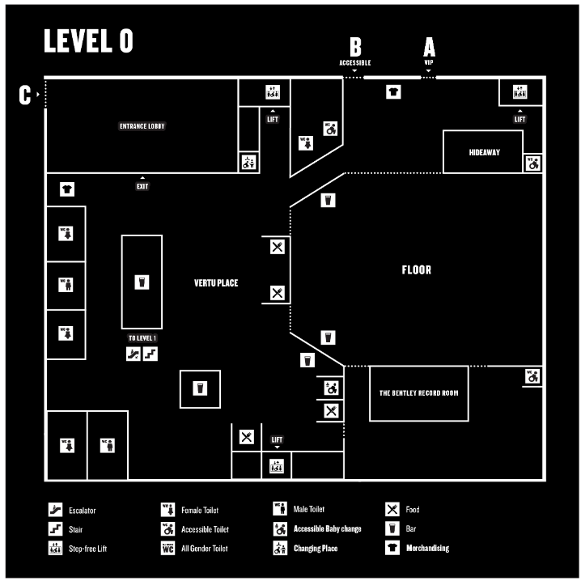
Where is the accessible drop-off point?
The accessible drop off point is at Entrance B on Forge Lane, M11 3DU. This is opposite Blue Car Park.
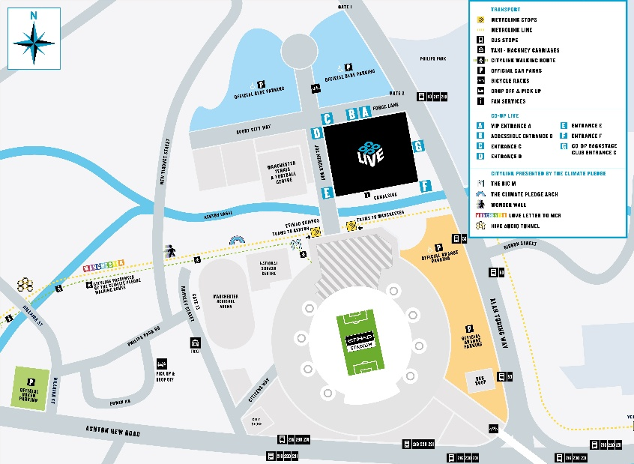

Accessible Parking
Is accessible parking available at Co-op Live?
Complementary accessible parking is available at Co-op Live, and must be reserved in advance. You can book parking online on our Parking Booking Page up to a month before the show date.
How do I book accessible parking?
Please choose your event and book accessible blue badge parking on our Parking Booking Page. You will need to provide a blue badge number and vehicle registration when making a selection. Parking opens up to a month before the show date, subject to availability.
How much does accessible parking cost?
Accessible parking is free of charge when providing a blue badge number and vehicle registration. You can book parking online on our Parking Booking Page, parking will be available to book up to a month before the show date.
Where is accessible parking located?
Accessible parking will be located as close to Co-op Live as we can accommodate. Please follow the signs upon arrival.
Are any types of accessible vehicles prohibited from parking at Co-op Live?
All blue badge accessible parking spaces are standard size. Please contact us should you require alternative arrangements.

What can I bring?
Can I bring my assistance dog to Co-op Live?
Assistance Dogs UK - ADUK registered assistance dogs are welcome at the venue. However, we recognise that not all assistance dogs are registered with Assistance Dogs UK Members and assistance dogs can be trained by their owners. We allow access to assistance dogs who are not formally trained by Assistance Dogs UK as long as they meet the Equalities and Human Rights Commission’s definition of an assistance dog.
This means your dog needs to have been trained:
• Not to wander around the premises or approach other customers.
• To only go to the toilet on command in a designated area of the event.
• To sit or lie quietly next to their owner.
Due to the crowded nature of our events and the low lighting conditions customers can experience, we request that your assistance dog wears a high vis jacket, even if they do not usually do so. This request is to ensure we meet customers’ access requirements while ensuring we also fulfil our legal obligation to provide a safe environment for all customers.
Event staff will be available to look after your assistance dog to allow you to fully enjoy the show. Please let us know in advance by contacting us if you are bringing your assistance dog to the venue or if you have any questions.
Please note that on rare occasions, we may need to relocate you to a more suitable seat should you wish to remain with your assistance dog.
Can I bring medical supplies, equipment, or necessary food and drink with me?
Although we don’t normally allow fans to bring supplies into the venue with them, we welcome fans who need to bring medical supplies, equipment or food and drink to manage medical conditions. Please contact us in advance should this be the case, providing as much detail as possible, including your seat number or ticket type so we can ensure the event teams are aware. A medical team will be available at each event.
Please note that on rare occasions, we may need to relocate you to a more suitable seat depending on the equipment you require to bring into the venue.
Can I bring walking sticks or crutches?
To protect everyone’s health and safety, any mobility aids are not allowed on the standing floor. This includes canes and wheelchairs. Foldable and straight walking sticks are allowed, however straight walking sticks cannot be used in standing areas, only seated areas.
Accessible platforms are available across all levels at Co-op Live, and we will always do our best to facilitate any last minute relocation requests.
Do you provide power supply if needed for my medical equipment?
Yes, we do. Please contact us to request this with one of our team in advance of the event.

Accessibility inside the venue
How do I move around inside Co-op Live if I have additional accessibility requirements?
All concourse levels within the venue can be accessed step-free. Four publicly accessible lifts will transport fans to all levels.
Venue and safety staff are available to guide and support where necessary.
Can I access restaurants, bars and merchandise if I have additional accessibility requirements?
All our bars, restaurants and lounges can be accessed step-free and include lowered counters for accessible ordering.
Venue and safety staff are available support where necessary.
Venue wheelchair/pushchair storage
The venue has a number of dedicated house wheelchairs, that can be accessed to move around the venue and to access seats. To request the use of a house wheelchair please speak a member of staff upon arrival at our accessible Entrance B, or speak to a member of the team at our fan service desk located on level 01 – opposite block 111.
Please note, house wheelchairs can only be used once inside venue and with the supervision of a member of the Co-op Live team. House wheelchairs can only be used to help move around the venue and not for the duration of the event.
Accessible toilet facilities
Accessible toilets are located throughout the venue. The venue has accessible toilets on
Level 00, Level 01, Level 02 and Level 03. These are marked on maps both inside the venue and on the Co-op Live app.
Accessible toilets are accessed via a Radar Key. If you require assistance accessing the toilets please speak to a member of staff on the night of the event.
The venue also has gender-neutral toilets available located on level 00, level 02 and level 03. These are marked on the maps both inside the venue and on the Co-op Live app.
Accessible changing places
The venue includes 2 fully accessible adult changing places. These facilities include:
- Toilet
- Adjustable changing bench
- Hoist
- Space for up to two personal assistants
The changing places are accessed via a Radar Key and are located on level 00 and level 01 opposite block 114. The location can also be found on maps throughout the venue or on the Co-op Live app.
If you require access to the changing places, please speak to a member of staff on the night of the event.
Are baby changing facilities available?
Baby changing facilities are available throughout the venue. These can be accessed within the general WC blocks throughout the venue as well as in the following locations:
Level 00 – Vertu Place
Level 01 – Outside Block 101 and 113
Level 02
Level 03
Level 04
Where are accessible platforms and seating located?
Wheelchair accessible platforms and seating are available on every level throughout the venue to ensure variety and choice for all our fans.
All accessible seating (including wheelchair access platforms) may vary depending on the show layout.
- Level 0
Entrance B is a dedicated accessible entrance with direct access onto the step-free Level 0 wheelchair accessible platform.
Note that access to floor seated tickets is not step-free. Access to the event floor requires 4 steps.
Seats in floor blocks D1 and D2 are then accessed via 3 steps, followed by 2 steps per row.
- Level 01
Step-free wheelchair access platforms are located on row 24 on blocks 102,103,104,105, 106,107,108,109,110,111,112,113 and 114.
Ambulant seating is also available on row 24, and will require 2 steps to access.
Visual impairment, hearing impairment and non-step free access seating (including some ambulant seating) are available throughout the venue clearly marked on Ticketmaster when booking tickets.
- Level 03
Our designated accessible platforms on Level 03 are currently unavailable. If you require step-free access, please contact the access team in advance prior to booking tickets on Level 03.
All blocks within level 3 do have handrails. Please note the handrails are not continuous, and there are 3 steps per row.
Do you allow mobility aids on the standing floor?
To protect everyone’s health and safety, any mobility aids are not allowed on the standing floor. This includes walking sticks, canes, and wheelchairs. Accessible platforms are available across all levels at Co-op Live, and we will always do our best to facilitate any last minute relocation requests.
Do you offer help to my seat? Is there a staxi wheelchair service?
Co-op Live offers a pushing and chaperone service from our ‘access point’, located close to Blue Badge Parking, to your seat. This service is open to anyone who needs additional support and is offered on a first come first served basis; this means wait times may vary. This service is not bookable.
What happens in an emergency if I have additional accessibility requirements?
Our emergency systems include both visual and audible warnings. Assistance will be provided and where necessary fans will be guided to a safe space or refuge for evacuation, including the use of evacuation lifts. Evacuation routes are signed throughout the venue.
Will there by any pyros, lasers and/or strobes at the event I’m attending?
Co-op Live shows often include special effects, including pyro, lasers and strobe lighting. Although we do our best to find out in advance, we can’t always let you know before the event if this is the case. Please speak to a member of staff on arrival if you are concerned about possible special effects or contact us in advance for more information where possible.
What is the respite room and how do I access it?
Co-op Live is building a designated respite space; a safe space accessible to all who need it, including those with anxiety.
Our stewarding team will be available to direct and grant access to you on the night. If you feel that you may require use of this space, please let us know in advance if you can by contacting us. The respite room is located on Level 1 on the Northeast corner of the venue, adjacent to the Co-op Backstage Club.

Accessible Performances
Are hearing assistance and induction loops available?
The venue has a fully accessible hearing loop that can be accessed from anywhere within the venue bowl.
Hearing loops can be loaned from Fan Services on Level 1.
If you require more information, please contact the venue directly.
Are British Sign Language (BSL) interpreters and assisted performances available?
If you require British Sign Language (BSL) interpreter, audio description or any other assisted performance, please contact the venue directly at least four weeks in advance of the event.
How can I raise a concern about special effects, including strobe lighting?
Events are likely to include special effects including strobe and flashing lights, smoke, haze, and pyrotechnics. Any effects being used in the performance will be displayed at all entry points to Co-op Live and the seating bowl. Please speak to a member of staff on arrival should this be a cause for concern or contact us in advance for more information where possible.

